[](http://www.google.co.uk/url?sa=i&rct=j&q=&esrc=s&frm=1&source=images&cd=&cad=rja&uact=8&ved=0ahUKEwjj_vyw5ojMAhVIvRoKHaQuBFkQjRwIBw&url=http://interiorstickers.co.uk/william-morris-1834-1896/&psig=AFQjCNGDtQrxV2ZGdTaZT3N3j09egHyChg&ust=1460540148603086)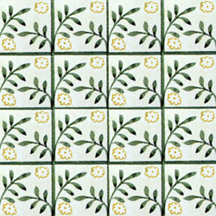

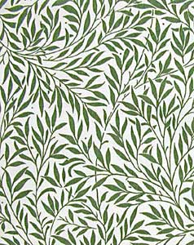

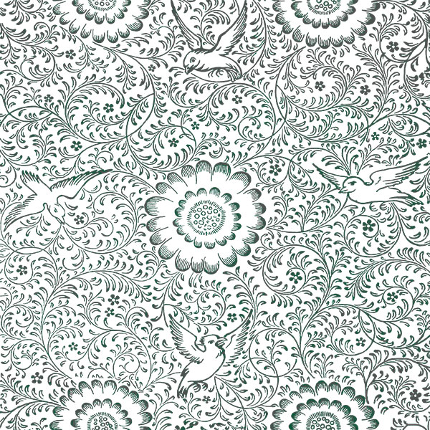

[](https://www.google.co.uk/url?sa=i&rct=j&q=&esrc=s&frm=1&source=images&cd=&cad=rja&uact=8&ved=0ahUKEwiwmfPH54jMAhXJXhoKHal9CpgQjRwIBw&url=https://www.pinterest.com/donnabaratta/william-morris/&psig=AFQjCNGDtQrxV2ZGdTaZT3N3j09egHyChg&ust=1460540148603086)